

**161120: Usama**

**161132: Sami Ahmed Malik**

**CarPool**

**Bachelor of Science in Computer Science**

Supervisor: M. Shoaib Malik

Co-Supervisor: Dr. Touseef

Department of Computer Science Air University, Islamabad

February 2020

# Certificate

We accept the work contained in the report titled“TITLEOFTHEREPORT”, written by Mr. AUTHOR1 NAME AND Mr. AUTHOR2 NAME as a confirmation to the required standard for the partial fulfillment of the degree of Bachelor of Science in Computer Science.

### Approved by:

Supervisor: Name of the Supervisor (Title)

Dr. Touseef

Internal Examiner: Name of the Internal Examiner (Title)

External Examiner: Name of the External Examiner (Title)

Project Coordinator: Name of the Project Coordinator (Title)

Head of the Department: Name of the HOD (Title)

May 15*th*, 2020

# Abstract

In general, people have a hard time conciliating their schedules because of the way they move from one location to another. And students suffer from this the most especially since transportation between cities is not that great, As students, we think there should exist more suitable transportation solutions to places where transportation networks are short and cheap and helpful for students.

This report proposes a platform to help improve students mobility through carpooling, a way for vehicle owning students to share their private vehicle with non vehicle owning students in order to splitting and reducing costs. Carpooling may be one of the best solutions when there is no other mean of transportation to a specific location but naturally it is not the only one. Mobile applications take more and more part of everyone’s lives, different services for carpooling with different features begin to compete with existing transportation solutions. Some people start to prefer using new carpooling services over the traditional services represented by taxi services. CarPool aims to promote carpooling by targeting students making it easier for them to adhere and use this system. By targeting students people will more likely join the service since its users are primarily other people form the same environment. To put the carpooling system in place, we have designed and developed an Android mobile application with backend servers for users to access the carpooling service through their smartphones, additionally the application involves some features that are critical to the service. By using Android Development Tools and Libraries and efficient backend solutions we have managed to make the application simple but powerful as well, which makes this application very useful for the students to use.

The combination of the smart phone and the Internet service is the trend of the future information development and software applications. Mobile phones are the most commonly used communication tools. Using mobile phones to obtain information is not only quick, but also more convenient shortcut to improve people's lives. In the paper, we propose the software development architecture based on Web services. This framework introduces the three-layer architecture of Web development into mobile phone software development. Based on the threelayer architecture, the android based CarPool system is developed.

Our app CarPool will be a unique carpooling application that would take benefits of the advantages of carpooling and try to improve and eliminate the disadvantages, all while focusing on making it a good carpooling experience for students. The realization of our project will go through the conceptual phase and then development phase. Since making a good application requires good planning first.

# Acknowledgments

We wish to thank various people for their contribution to this project.we would like to express our deep gratitude to Sir Shoaib Malik, our Project supervisor, for their patient guidance, enthusiastic encouragement and useful critiques of this Project work. we would also like to thank Dr Touseef, our project co-supervisor for his advice and assistance in keeping our progress on schedule.

we would also like to extend our thanks to the librarians of the Air University for their help in offering us the resources in running the program.

Finally, We wish to thanks our parents for their support and encouragement throughout our study.

Usama, Sami Ahmed Malik

Islamabad, Pakistan

May 2020

# Table of Contents

Certificate 2

Approved by: 2

Abstract 3

Acknowledgments 4

Table of Contents 5

List of Figures 7

List of Tables 8

1. Introduction 9

1.1 What is CarPool? 9

1.1.1. Project Background/ Review 9

1.1.2. Problem description 9

1.1.3. Project Objectives 10

1.1.4. Project Scope 10

1.2 The Degree of Project Report 10

2. Literature Review 11

Carpooling 11

3. Requirement Specification 12

3.1 Existing System for carpooling 12

3.2 Proposed System 13

3.3 Requirement Specifications 13

3.3.1. Functional Requirements 13

3.3.2. Non-Functional Requirements 17

3.4 Use Cases 19

3.4.1. Use Case Diagram 19

3.4.2. Use Case Description 21

4. Design 27

4.1 System Architecture 27

4.1.1. High Level Context Diagram 27

4.2 Design Constraints 28

4.3 Design Methodology 29

4.4 High-Level Design 29

4.4.1. Conceptual or Logical: UML Package diagram 29

4.4.2. Process Interaction Diagram 30

4.4.3. Physical: Deployment Diagram 32

4.4.4. Module 32

4.4.5. Security 33

4.5 Low-Level Design 33

4.6 Database Design 33

4.7 GUI Design 34

4.7.1 Login and Signup Screens 34

4.7.2 Rider Screens 35

4.7.3 Driver Screens 36

5. System Implementation 38

5.1 SystemArchitecture 38

5.2 Work Environment 39

5.2.1 Hardware platforms 39

5.2.2 Software platforms 39

5.2.3 Work Tools 39

5.2.4 Programming languages: 39

5.2.5 Frameworks used: 39

5.2.6 Database Management System 40

5.3 Tools & Technology 41

5.4 System requirements 42

5.5 Security 42

5.5 Rules 42

6. System Testing and Evaluation 42

6.1 Graphical user interface testing 43

6.2 Usability Testing 43

6.3 Software performance testing 45

6.4 Compatibility testing 46

6.5 Exception handling 46

6.6 Security testing 47

6.7 Installation testing 48

7. Conclusion 49

User Manual 50

References 51

# List of Figures

Figure 1: Context Diagram 27

Figure 2: Subsystem 28

Figure 3: Package Diagram 29

Figure 4: Interaction Diagram 30

Figure 5: Deployment Diagram 31

Figure 6: low-level design 32

Figure 7: System Architecture 41

# List of Tables

Table 1: Functional Requirement - 01 12

Table 2: Functional Requirement - 02 13

Table 3: Functional Requirement - 03 13

Table 4: Functional Requirement - 04 13

Table 5: Functional Requirement - 05 14

Table 6: Functional Requirement - 06 14

Table 7: Functional Requirement - 07 14

Table 8: Functional Requirement - 08 15

Table 9:Functional Requirement - 09 15

Table 10: Non-Functional Requirement-01 16

Table 11: Non-Functional Requirement-02 16

Table 12: Non-Functional Requirement - 03 16

Table 13: Non-Functional Requirement - 04 16

Table 14: Non-Functional Requirement - 05 16

Table 15: Non-Functional Requirement - 06 17

Table 16: Non-Functional Requirement - 07 17

Table 17: Non-Functional Requirement - 08 17

Table 18: Non-Functional Requirement - 09 17

Table 19: Non-Functional Requirement - 10 17

Table 20: Non-Functional Requirement - 11 18

Table 21: Use Case - 01 19

Table 22: Use Case - 02 19

Table 23: Use Case - 03 20

Table 24: Use Case - 04 20

Table 25: Use Case - 05 21

Table 26: Use Case - 06 21

Table 27: Use Case - 07 22

Table 28: Use Case - 08 22

Table 29: Use Case - 09 23

Table 30: Use Case - 10 23

Table 31: Use Case - 11 24

Table 32: Use Case - 12 25

Table 33: Use Case - 13 25

Table 34: Use Case - 14 26

Table 35: user interface testing 43

Table 36: Usability Testing 44

Table 37: performance testing 45

Table 38: Compatibility testing 46

Table 39: exception handling 46

Table 40: Security Testing 47

Table 41: installation testing 48

# Introduction

## 2.1 What is CarPool?

### 2. Project Background/ Review

Carpooling (also car-sharing, ride-sharing and lift-sharing) is the sharing of car journeys so that more than one person travels in a car, and prevents the need for others to have to drive to a location themselves.

Drivers and passengers offer and search for journeys through one of the several mediums available. After finding a match they contact each other to arrange any details for the journey(s). Costs, meeting points and other details like space for luggage are agreed on. They then meet and carry out their shared car journey(s) as planned.

By having more people using one vehicle, carpooling reduces each person's travel costs such fuel costs, tolls and the stress of driving. Authorities often encourage carpooling, especially during periods of high pollution or high fuel prices. Car sharing is a good way to use up the full seating capacity of a car, which would otherwise remain unused if it were just the driver using the car.

In 2009, carpooling represented 43.5% of all trips in the United States and 10% of commute trips. The majority of carpool commutes (over 60%) are "fam-pools" with family members.

In 2011, an organization called Greenock created a campaign to encourage others to use this form of transportation in order to reduce their own carbon footprint.

Carpooling, or car sharing as it is called in British English, is promoted by a national UK charity, Carplus, whose mission is to promote responsible car use in order to alleviate financial, environmental and social costs of motoring today, and encourage new approaches to car dependency in the UK. Carplus is supported by transport for London, the British government initiative to reduce congestion and parking pressure and contribute to relieving the burden on the environment and to the reduction of traffic-related air-pollution.

Cabbing All the Way is a book written by author Jatin Kuberkar that narrates a success story of a carpool with twelve people on board. Based in the city of Hyderabad, India, the book is a real-life narration and highlights the potential benefits of having a carpool

### Problem description

Many vehicle-owning Students who commute on daily basis often have unoccupied seats in their vehicles. Many non-vehicle owning students find it very difficult sometimes to find ride for travelling to and from university.

### Project Objectives

Objective

* To Allow vehicle owning students to share their rides with other students for traveling to and from their institutes and cut down their fuel bills.
* To facilitate non-vehicle owning students for travelling to and from university easier and cheaper.

Goals

* Cost Effective: Much Cheaper than Cab services.
* Ease of getting ride: Riders are easy approachable, which reduces the tension of finding and catching of local transport right on time.
* Fewer Cars on the road will have reduced fuel consumption which will make environment Eco-friendly.

### Project Scope

This project (CarPool) aims to develop an Android based application for carpooling

for students, this application allows vehicle owning students to submit rides for specific

targets and allows passengers to reserve/request rides from drivers all while being secure

and having a simple interface.

This application will help students save money and also reduce the pollution of the

environment and effects of vehicles, this application focuses on serving needs of students.

CarPool will be intended for the students in Air University and it will support Android phones

and Tablets, Users will need internet connection to use the application to offer or find a

common route to travel to,

The application will have a simple and easy interface, Users must register at first before

using the application, after that they must choose between a driver or a passenger, a driver

can offer a drive to a specific location while a passenger can find or request a ride to a location.

## The Degree of Project Report

In our FYP-1, we presented our idea that how CarPool would be beneficial. The only purpose of FYP-1 was to present and defend the idea. We have completed both tasks successfully and we also developed some mockup screens to present our idea.

However, in fyp-2, the task assigned to us was to develop a working application for two users: driver and rider along with the implementation of the core feature of our application, which was location tracking of driver and rider, fetching current location, use Firebase it’s Real-time Database which is a NoSQL Fast Databaseand displaying that location on the map using Google Map API.

# Literature Review

## 2.1 Carpooling

### 2.1.1. Definition and general principle

Carpooling (also car-sharing, ride-sharing and lift-sharing) is the sharing of car journeys so that more than one person travels in a car, and prevents the need for others to have to drive to a location themselves.

By having more people using one vehicle, carpooling reduces each person's travel costs

such as: fuel costs, tolls, and the stress of driving. Carpooling is also a more environmentally

friendly and sustainable way to travel as sharing journeys reduces air pollution, carbon

emissions, traffic congestion on the roads, and the need for parking spaces. Authorities

often encourage carpooling, especially during periods of high pollution or high fuel prices.

Car sharing is a good way to use up the full seating capacity of a car, which would otherwise

remain unused if it were just the driver using the car.

In 2009, carpooling represented 43.5% of all trips in the United States and 10% of

commute trips. The majority of carpool commutes (over 60%) are "fam-pools" with family

members.

Carpool commuting is more popular for people who work in places with more jobs

nearby, and who live in places with higher residential densities. Carpooling is significantly

correlated with transport operating costs, including fuel prices and commute length, and

with measures of social capital, such as time spent with others, time spent eating and

drinking and being unmarried. However, carpooling is significantly less likely among

people who spend more time at work, elderly people, and homeowners.

Carpooling usually means to divide the travel expenses equally between all the

occupants of the vehicle (driver or passenger). The driver does not try to earn money, but

to share with several people the cost of a trip he would do anyway. The expenses to be

divided basically include the fuel and possible tolls. But if we include in the calculation the

depreciation of the vehicle purchase and maintenance, insurance and taxes paid by the

driver, we get a cost around 100DA/km. There are platforms that facilitate carpooling by

connecting people seeking respectively passengers and drivers. Usually there is a fare set

up by the car driver and accepted by passengers because they get an agreement before trip

start.

## 2.2 Carpooling Types

### 2.2.1. Regular

The car is often perceived as an extension of the personal space, the driver, alone in

his vehicle is in a closed space; he is free to do what he likes: listen to the radio, sing, call

with headsets ... Carpooling regularly is to share a dialogue, experiences, stories.

In the United States an intermediate concept has developed between carpooling and

the public transport line: the Vanpool. These are minibuses chartered by an employer, a

public authority or a private company and made available to a group of people who

regularly make the same journey.

### 2.2.2. Occasional

This type of carpooling is mainly used for leisure or last minute departures. The

linking is often done through websites or mobile applications, which can significantly

reduce travel costs, but usually requires to carpool with one or more unknown.

### 2.2.3. Eventual

Participants in an event (music festival, sporting event, wedding, associative or

institutional meeting ...) can organize to carpool to the venue of the event. This one-time

carpool has a special feature: all participants travel to the same place on the same date.

Carpooling is also used for departures on holidays or weekends, savings on a trip

being even larger than the trip is long. So carpooling becomes an alternative of affordable

and accessible transportation.

There are also "cultural" carpooling platforms to visit a cultural site: castles,

museums, exhibitions, artists' studios, religious places, festivals, etc.

# Requirement Specification

## Existing System for carpooling

Many carpoolings applications and websites have been developed around the world. A similar carpooling system was developed in Massey University New Zealand by a group of students to allow students of Massey University, Albany campus to share their vehicle with non-vehicle owning students.

Following some examples of carpooling systems around the globe

### 3.1.1. Websites

* New Zealand: <https://www.asa.ac.nz/carpool>
* Algeria: www.nroho.com, www.m3aya.com,www.nsogo.net
* Europe: BlaBlaCar.com, carpooling.com, GoMore.com
* France: covoiturage.fr
* USA: car.ma , www.rdvouz.com
* World: Outpost.travel , joinntravel.com , [www.letsride.in](http://www.letsride.in)

## 3.1.2. Mobile Applications

* New Zealand: ASA
* Algeria: YAssir,Nsogo, AMIR
* World: Uber, sRide, RideShare,
* USA: Uber, Lyft
* France: Karos, Wever, BlaBlaCar, OuiHop

## Proposed System

Our purposed system is a “Carpool” application which is a ride sharing application designed just for students.students can login or signup to this application only via university email id to make sure that only enrolled students in a university used this application.

Vehicle owning students can share their rides with other students for traveling to and from their institutes and earn money.

## Requirement Specifications

It involves functional and non-functional functionalities that must be performed by the system:

### 3.3.1. Functional Requirements

Table 1: Functional Requirement - 01

|  |  |
| --- | --- |
| Identifier | FR-01 |
| Title | Create Account |
| Requirement | Registered New User |
| Source | Supervisor, M. Shoaib Malik |
| Rationale | To registered new users |
| Restrictions and Risk | User can only be registered via university email |
| Dependencies | Android phone, Google API, Firebase server, Firebase Authentication |
| Priority | High |

Table 2: Functional Requirement - 02

|  |  |
| --- | --- |
| Identifier | FR-02 |
| Title | Sign In |
| Requirement | Already registered |
| Source | Supervisor, M. Shoaib Malik |
| Rationale | It’s essential to use this application |
| Restrictions and Risk | User must be registered on this application |
| Dependencies | Google API, Firebase server, Firebase Authentication |
| Priority | High |

Table 3: Functional Requirement - 03

|  |  |
| --- | --- |
| Identifier | FR-03 |
| Title | Reset Password |
| Requirement | Already registered on this application. |
| Source | Supervisor, M. Shoaib Malik |
| Rationale | Reset user account password |
| Restrictions and Risk | Have access to university email |
| Dependencies | Firebase server, Firebase Authentication, Google Map Api |
| Priority | Low |

Table 4: Functional Requirement - 04

|  |  |
| --- | --- |
| Identifier | FR-04 |
| Title | Switch to Driver / Rider |
| Requirement | Sign In |
| Source | Supervisor, M. Shoaib Malik |
| Rationale | Confirm the role of user |
| Restrictions and Risk | User have to choose only one role at a time. |
| Dependencies | Firebase server |
| Priority | Medium |

Table 5: Functional Requirement - 05

|  |  |
| --- | --- |
| Identifier | FR-05 |
| Title | Vehicle Details (Driver) |
| Requirement | Choose vehicle type car / bike |
| Source | Supervisor, M. Shoaib Malik |
| Rationale | To make sure the vehicle type and detail |
| Restrictions and Risk | Nil |
| Dependencies | Firebase server |
| Priority | Medium |

Table 6: Functional Requirement - 06

|  |  |
| --- | --- |
| Identifier | FR-06 |
| Title | Create Ride (Driver) |
| Requirement | Choose role of a driver |
| Source | Supervisor, M. Shoaib Malik |
| Rationale | Select riders from list |
| Restrictions and Risk | Driver have to choose only certain number of riders according to free seating capacity. |
| Dependencies | Firebase server, Google Map Api |
| Priority | Medium |

Table 7: Functional Requirement - 07

|  |  |
| --- | --- |
| Identifier | FR-07 |
| Title | End Ride (Driver) |
| Requirement | Driver ends the ride. |
| Source | Supervisor, M. Shoaib Malik |
| Rationale | To make sure all riders dropped. |
| Restrictions and Risk | Nill |
| Dependencies | firebase server, Google Api |
| Priority | Medium |

Table 8: Functional Requirement - 08

|  |  |
| --- | --- |
| Identifier | FR-08 |
| Title | Book Ride (Rider) |
| Requirement | Choose role of a rider. |
| Source | Supervisor, M. Shoaib Malik |
| Rationale | Select destination and pickup point |
| Restrictions and Risk | Rider have to choose only available pickup point. |
| Dependencies | Firebase server, Google Map Api |
| Priority | Medium |

Table 9:Functional Requirement - 09

|  |  |
| --- | --- |
| Identifier | FR-09 |
| Title | Ride End (Rider) |
| Requirement | Driver pick the rider |
| Source | Supervisor, M. Shoaib Malik |
| Rationale | To make sure that driver drops a rider to destination. |
| Restrictions and Risk | Nil |
| Dependencies | Firebase server |
| Priority | Medium |

### 

### 3.3.2. Non-Functional Requirements

Table 10: Non-Functional Requirement-01

|  |  |
| --- | --- |
| Identifier | NFR-01 |
| Title | User Authentication |
| Requirement | User must be registered via university email id |

Table 11: Non-Functional Requirement-02

|  |  |
| --- | --- |
| Identifier | FR-02 |
| Title | Real time location tracking |
| Requirement | Mobile phone must be provide accurate GPS location of device. |

Table 12: Non-Functional Requirement - 03

|  |  |
| --- | --- |
| Identifier | FR-03 |
| Title | Multi-user system |
| Requirement | Efficient use of the system when the user increases. |

Table 13: Non-Functional Requirement - 04

|  |  |
| --- | --- |
| Identifier | FR-04 |
| Title | Internet connection |
| Requirement | User device must have a internet connection. |

Table 14: Non-Functional Requirement - 05

|  |  |
| --- | --- |
| Identifier | FR-05 |
| Title | Device compatibility |
| Requirement | Use of latest APIs and application must support most of android phone versions |

Table 15: Non-Functional Requirement - 06

|  |  |
| --- | --- |
| Identifier | FR-06 |
| Title | User friendly application |
| Requirement | Easy interface of application, not makes a user to think twice. |

Table 17: Non-Functional Requirement - 08

|  |  |
| --- | --- |
| Identifier | FR-08 |
| Title | Application limited to university students |
| Requirement | Only students with university email able to use bus system |

## 3.4 Use Cases

### 3.4.1. Use Case Diagram

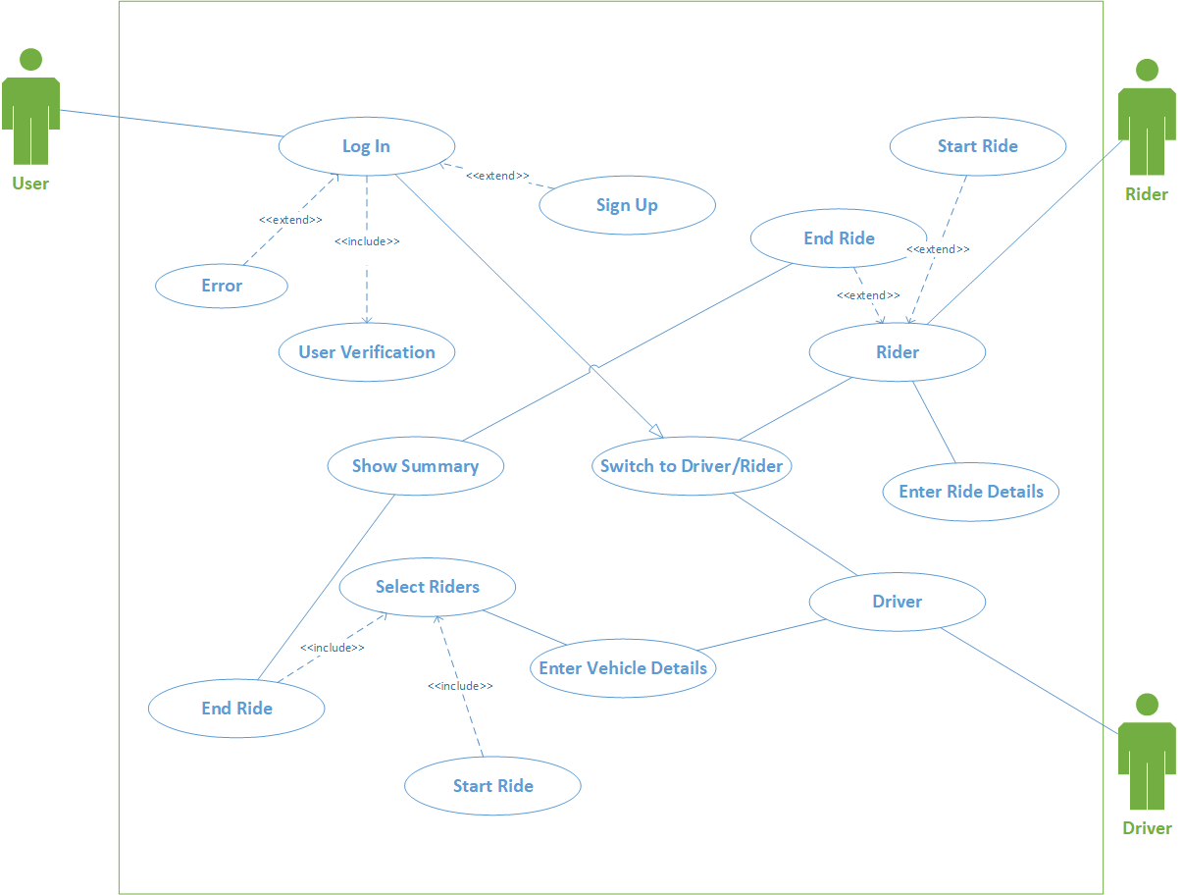

### 3.4.2. Use Case Description

Table 21: Use Case - 01

|  |  |
| --- | --- |
| **Use Case ID:** | UC-01 |
| **Use Case Name:** | Login |
| **Actors:** | Rider, driver |
| **Description:** | Signing in to use the application |
| **Trigger:** | Perform certain tasks based on user type |
| **Preconditions:** | Splash screen |
| **Postconditions:** | Home screen based on user type |
| **Normal Flow:** | Successful sign in |
| **Alternative Flows:** | Sign in failed, try again or reset password |
| **Exceptions:** | The account doesn’t exist |
| **Includes:** | Verify password |
| **Assumptions:** | User has an account |
| **Notes and Issues:** | nil |

Table 22: Use Case - 02

|  |  |
| --- | --- |
| **Use Case ID:** | UC-02 |
| **Use Case Name:** | Sign Up |
| **Actors:** | Driver, Rider |
| **Description:** | To use this application registration is required |
| **Trigger:** | Registered on this application |
| **Preconditions:** | Enrolled in a university |
| **Postconditions:** | Have access to university email for account verification |
| **Normal Flow:** | Log in to application |
| **Alternative Flows:** | Not eligible for registration |
| **Exceptions:** | University Email is not verified |
| **Includes:** | Must have access to university email |
| **Assumptions:** | User is enrolled in a universirty |
| **Notes and Issues:** | User can be registered only via university email |

Table 23: Use Case - 03

|  |  |
| --- | --- |
| **Use Case ID:** | UC-03 |
| **Use Case Name:** | Select User Type |
| **Actors:** | Driver, Rider |
| **Description:** | Switch according to your need |
| **Trigger:** | User Switch to particular user type |
| **Preconditions:** | Login |
| **Postconditions:** | User either act as a rider or driver |
| **Normal Flow:** | Switch to splash screen according to user type |
| **Alternative Flows:** | Nil |
| **Exceptions:** | Nil |
| **Includes:** | User have to choose user type |
| **Assumptions:** | Both type users are university students. |
| **Notes and Issues:** | Nil |

Table 24: Use Case - 04

|  |  |
| --- | --- |
| **Use Case ID:** | UC-04 |
| **Use Case Name:** | Driver |
| **Actors:** | Driver |
| **Description:** | User can acts as a driver |
| **Trigger:** | User acts as a driver |
| **Preconditions:** | User type switch screen |
| **Postconditions:** | User select riders |
| **Normal Flow:** | User is now acts as a driver |
| **Alternative Flows:** | Nil |
| **Exceptions:** | Nil |
| **Includes:** | User must have vehicle |
| **Assumptions:** | Driver must be student |
| **Notes and Issues:** | Nil |

Table 25: Use Case - 05

|  |  |
| --- | --- |
| **Use Case ID:** | UC-05 |
| **Use Case Name:** | Rider |
| **Actors:** | Rider |
| **Description:** | User can acts as a rider |
| **Trigger:** | User acts as a rider |
| **Preconditions:** | User type switch screen |
| **Postconditions:** | Enter ride details |
| **Normal Flow:** | Now user acts as a driver |
| **Alternative Flows:** | Nil |
| **Exceptions:** | Nil |
| **Includes:** | Rider is non-vehicle owning person |
| **Assumptions:** | Rider is a student |
| **Notes and Issues:** | Nil |

Table 26: Use Case - 06

|  |  |
| --- | --- |
| **Use Case ID:** | UC-06 |
| **Use Case Name:** | Enter vehicle details |
| **Actors:** | Driver |
| **Description:** | User acts as a driver and enter the vehicle detail |
| **Trigger:** | Enter vehicle details |
| **Preconditions:** | Switch to driver |
| **Postconditions:** | Select riders |
| **Normal Flow:** | Select vehicle type and enter vehicle details |
| **Alternative Flows:** | Nil |
| **Exceptions:** | Nil |
| **Includes:** | User vehicle details update to database server |
| **Assumptions:** | Nil |
| **Notes and Issues:** | Nil |

Table 27: Use Case - 07

|  |  |
| --- | --- |
| **Use Case ID:** | UC-07 |
| **Use Case Name:** | Enter ride detail |
| **Actors:** | Rider |
| **Description:** | Show current location of rider and rider have to select pickup point and drop off points. |
| **Trigger:** | Display user current location on map and pickup points list . |
| **Preconditions:** | User switch to rider mode. |
| **Postconditions:** | Wait for driver |
| **Normal Flow:** | Display current location from GPS and show list of drop off and pick up points. |
| **Alternative Flows:** | Nil |
| **Exceptions:** | Device GPS location access not given by user |
| **Includes:** | Loading current location from GPS and update data to server |
| **Assumptions:** | Nil |
| **Notes and Issues:** | Nil |

Table 28: Use Case - 08

|  |  |
| --- | --- |
| **Use Case ID:** | UC-08 |
| **Use Case Name:** | Start ride (Driver) |
| **Actors:** | Driver |
| **Description:** | After selection of passengers, driver has to start a ride |
| **Trigger:** | Start ride |
| **Preconditions:** | Select riders from list |
| **Postconditions:** | Drop riders and end ride |
| **Normal Flow:** | Ride is start and notified detail of driver to riders |
| **Alternative Flows:** | Ride cancel |
| **Exceptions:** | Riders not available |
| **Includes:** | Must have to select riders to start ride |
| **Assumptions:** | Riders available |
| **Notes and Issues:** | Nil |

Table 29: Use Case - 09

|  |  |
| --- | --- |
| **Use Case ID:** | UC-09 |
| **Use Case Name:** | Start Ride (Rider) |
| **Actors:** | Rider |
| **Description:** | Start ride when driver pick up the rider |
| **Trigger:** | Start ride |
| **Preconditions:** | Enter ride details |
| **Postconditions:** | End ride |
| **Normal Flow:** | Start ride and display driver details to rider |
| **Alternative Flows:** | Nil |
| **Exceptions:** | Driver is not availabe |
| **Includes:** | Must enter ride details |
| **Assumptions:** | Driver available |
| **Notes and Issues:** | Nil |

Table 30: Use Case - 10

|  |  |
| --- | --- |
| **Use Case ID:** | UC-10 |
| **Use Case Name:** | End ride (Driver) |
| **Actors:** | Driver |
| **Description:** | After drops the riders end the ride and summary of current ride is shown. |
| **Trigger:** | Ride End and show summary |
| **Preconditions:** | Start Ride |
| **Postconditions:** | Show summary |
| **Normal Flow:** | Succesfully end ride and show summary of current ride |
| **Alternative Flows:** | Nil |
| **Exceptions:** | Nil |
| **Includes:** | Driver drops all riders to their drop off locations |
| **Assumptions:** | Nil |
| **Notes and Issues:** | Nil |

Table 31: Use Case - 11

|  |  |
| --- | --- |
| **Use Case ID:** | UC-11 |
| **Use Case Name:** | End ride (Rider) |
| **Actors:** | Rider |
| **Description:** | Ride is end by rider and show the summary of ride |
| **Trigger:** | End ride and show ride details |
| **Preconditions:** | Pick up by driver |
| **Postconditions:** | Show summary of ride |
| **Normal Flow:** | Succesfully ride End and show summary of ride. |
| **Alternative Flows:** | Nil |
| **Exceptions:** | Nil |
| **Includes:** | Driver drops the rider to their drop off location |
| **Assumptions:** | Nil |
| **Notes and Issues:** | Nil |

# 

# 4. Design

## System Architecture

### 4.1.1. High Level Context Diagram

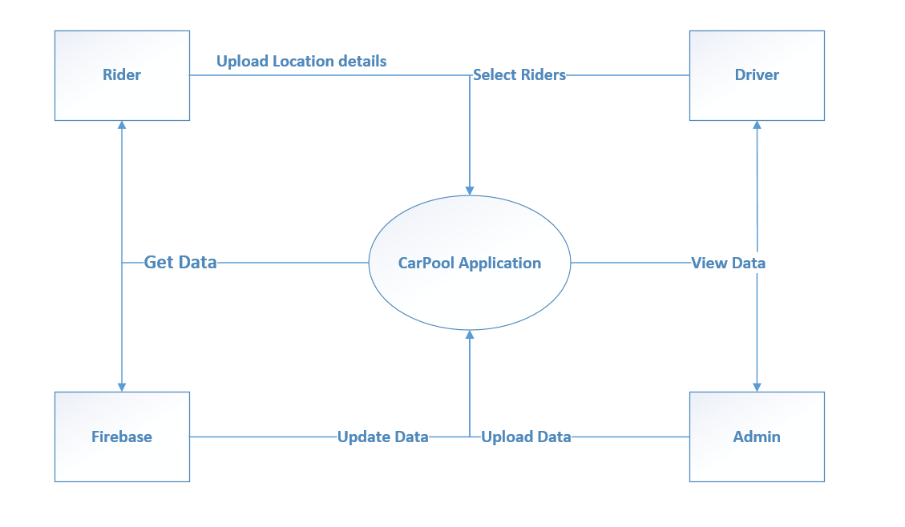

Figure 1: Context Diagram

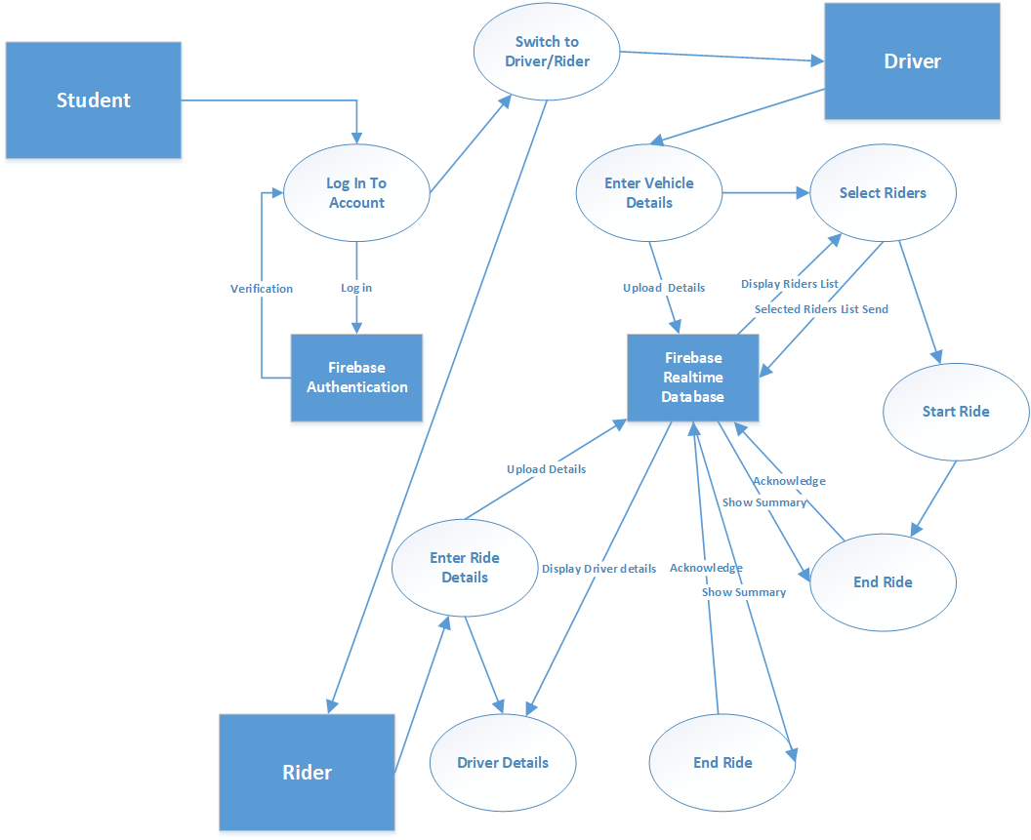

Figure 2: Subsystem

### 4.2 Design Constraints

In our application we add a list of pick up points for the ease of drivers. This is made easier when clients can select pick up points and drivers reach the destination without hassle. Due to the COVID-19 pandemic, we could not be supervised and guided properly. Hence this process was not added and executed.

### 4.3 Design Methodology

The design of a project is important for the structure of the application by using UML (Unified Modeling Language) which is a general purpose modelling language, that aims to define a standard way to visualize the way a system has been designed. It is quite similar to blueprints used in other fields of engineering.

**Reasons to use UML for project analysis and design are:**

● Complex applications need collaboration and planning from multiple teams and hence require a clear and concise way to communicate amongst them.

● A lot of time is saved down the line when teams are able to visualize processes, user interactions and static structure of the system.

These project designs will try and make the overall idea of the project more

understandable and clear by identifying Actors and functional / non-functional needs,

And also all the diagrams needed to give a clear view about this project.

### 4.4 High-Level Design

### 4.4.1. Conceptual or Logical: UML Package diagram

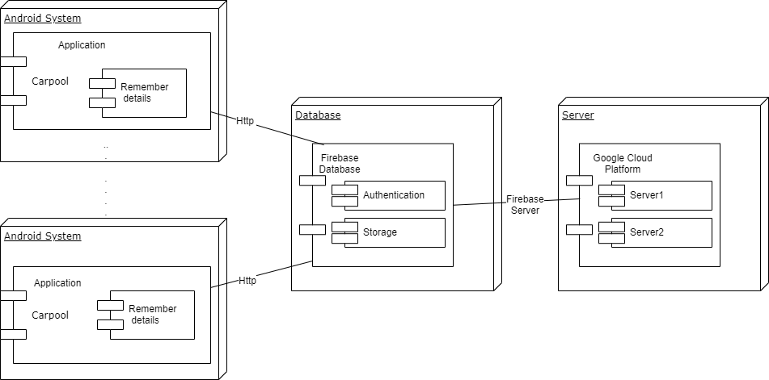

Figure 3: Package Diagram

### 4.4.2. Process Interaction Diagram

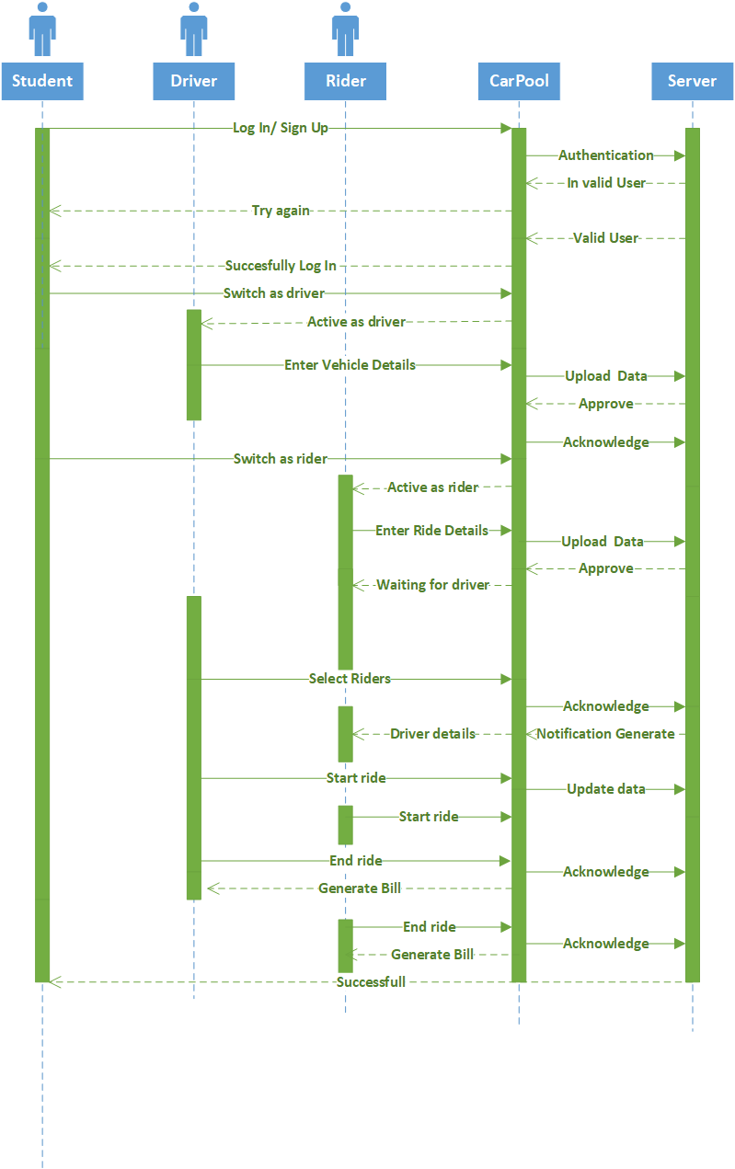

Figure 4: Interaction Diagram

### 4.4.3. Physical: Deployment Diagram

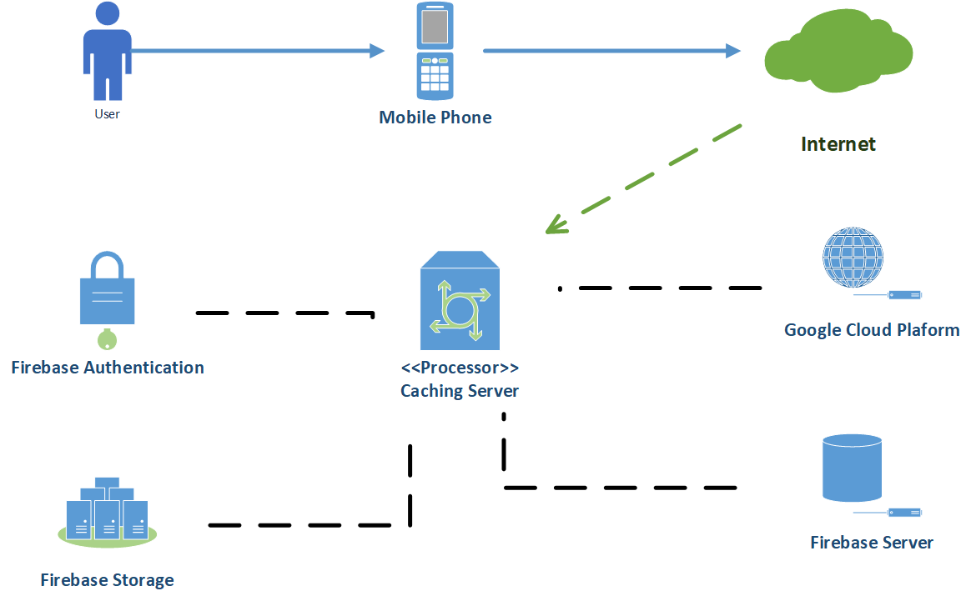

Figure 5: Deployment Diagram

### 4.4.4. Module

// I don’t know what to write here

### 4.4.5. Security

// I don’t know what to write here

### 4.5 Low-Level Design

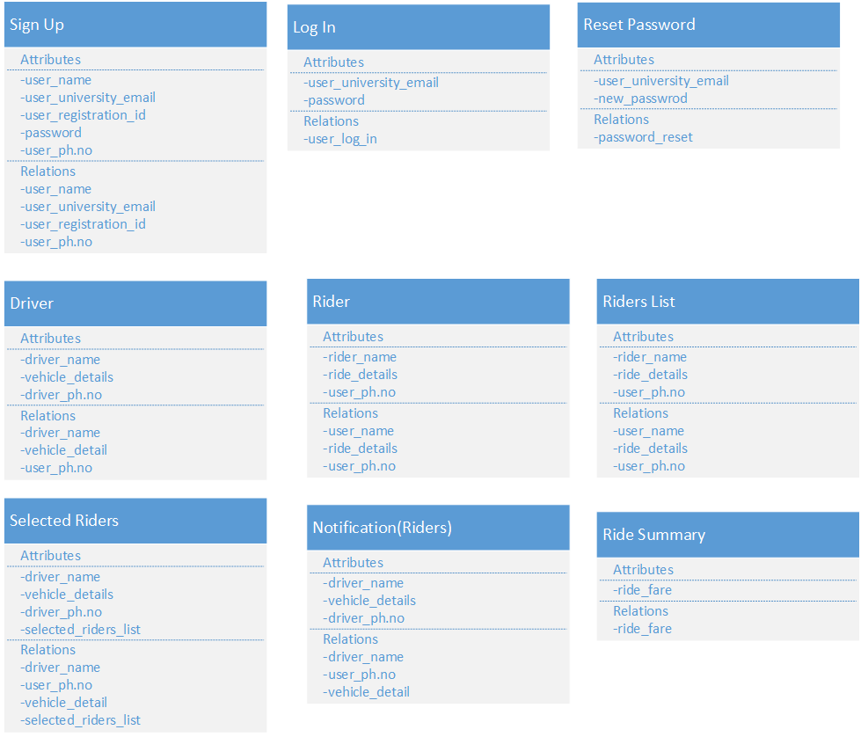

Figure 6: low-level design

### 4.6 Database Design

Firebase platform provides a cloud-hosted Realtime Database. It is a NoSQL cloud database. Data synchronizes among all clients and stays available even when the app goes offline. As it is a NoSQL database, so its functionality is different as compared to a relational database. The data is stored in the form of collections and documents. There is no relationship between classes, so there won’t be any schema of our database. Data gets stored as JSON objects. It is more like a cloud-hosted JSON tree. When a person adds data to the JSON tree, it becomes a node in the existing JSON structure with an associated key. The best method is to use the denormalization technique; using which we split data into separate paths. It becomes easier to download the data in separate calls as required.

### 4.7 GUI Design

Our application contains more than fifteen screens, different screens based on user type are:

### 4.7.1 Login and Signup Screens

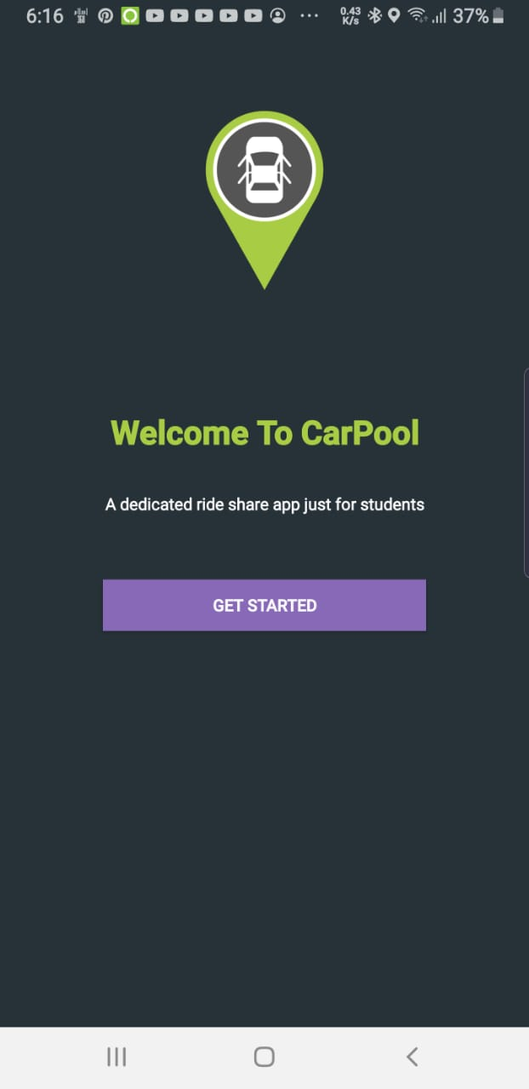 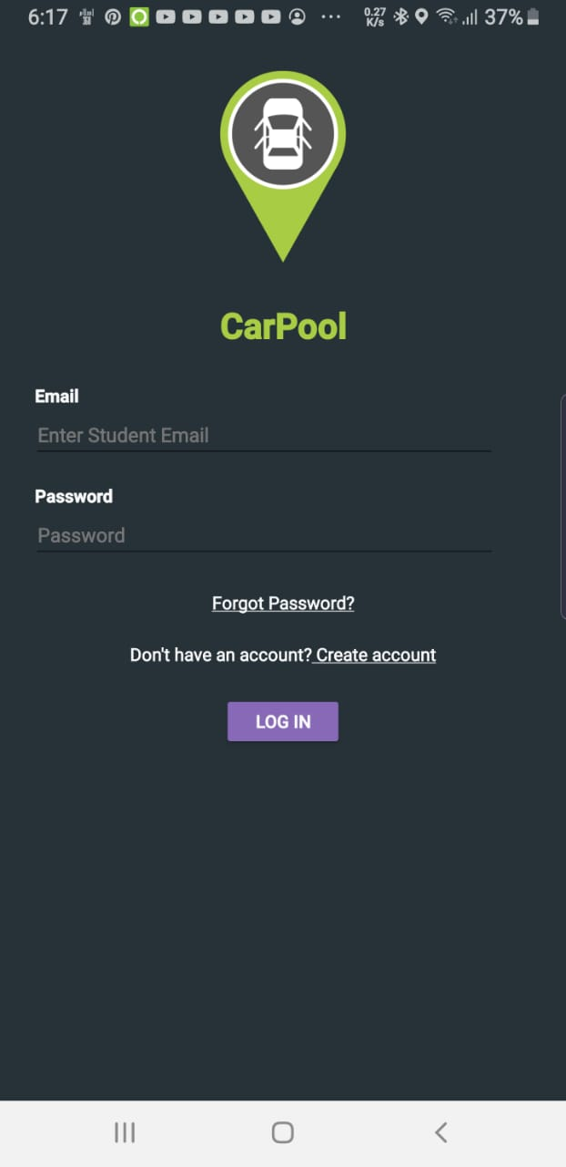

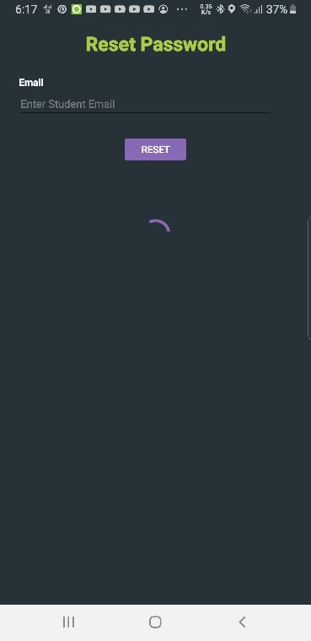 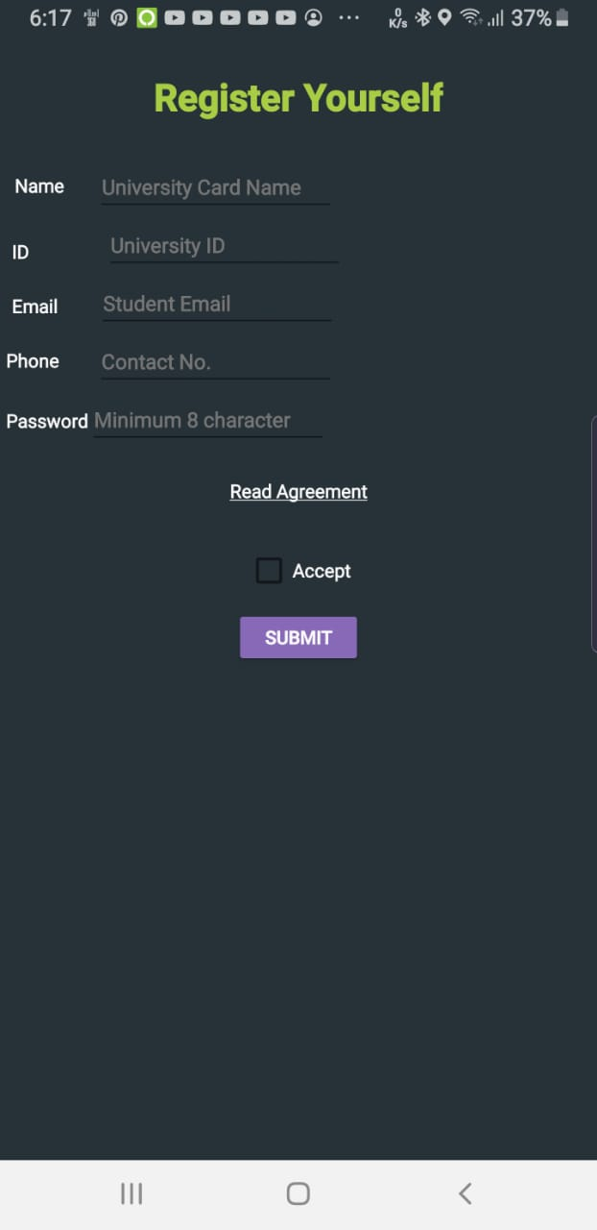 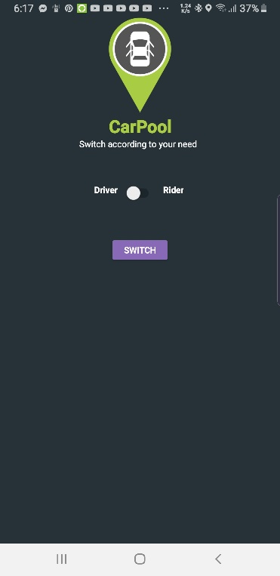

### 4.7.2 Rider Screens

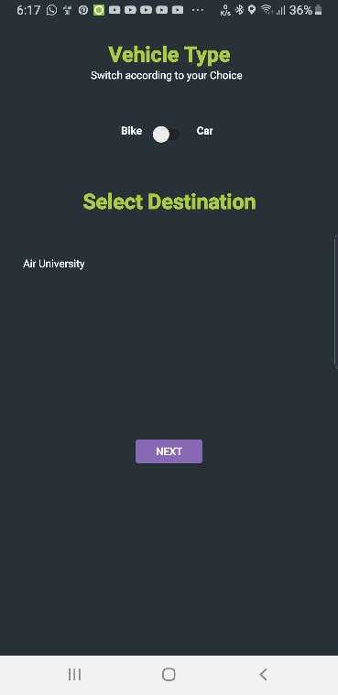 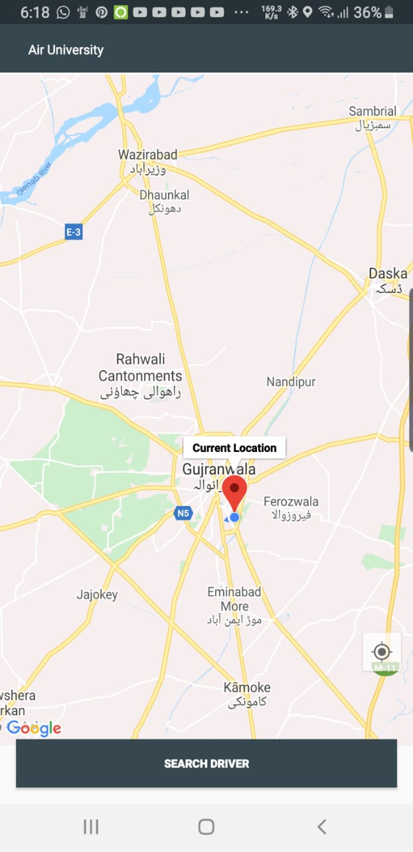 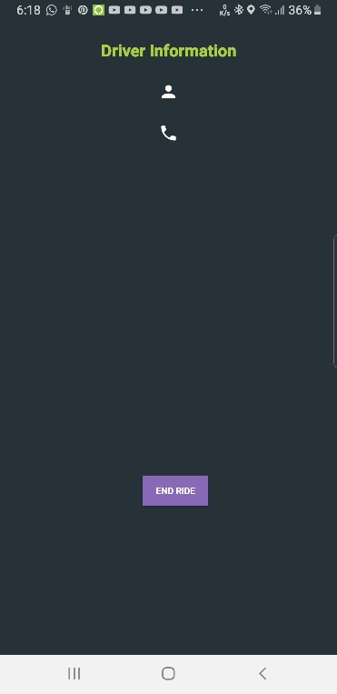

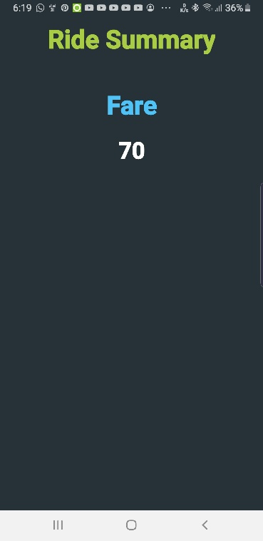

### 4.7.3 Driver Screens

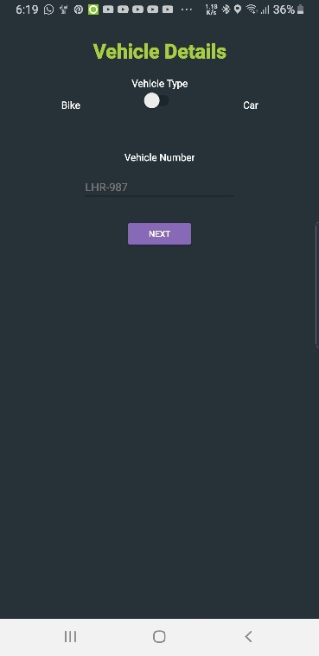 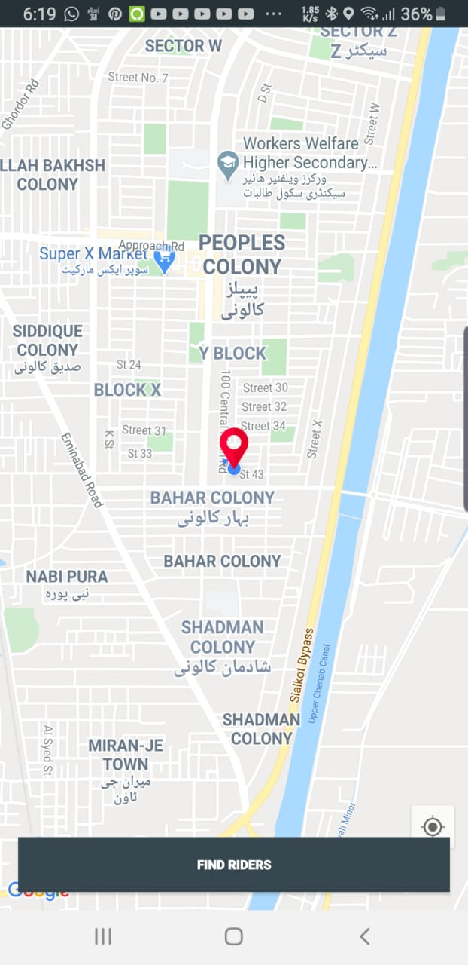 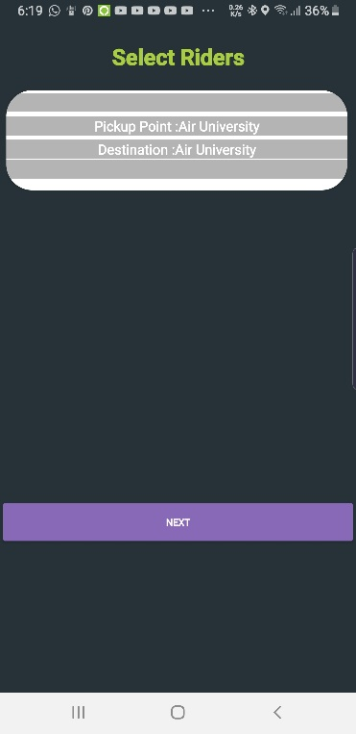

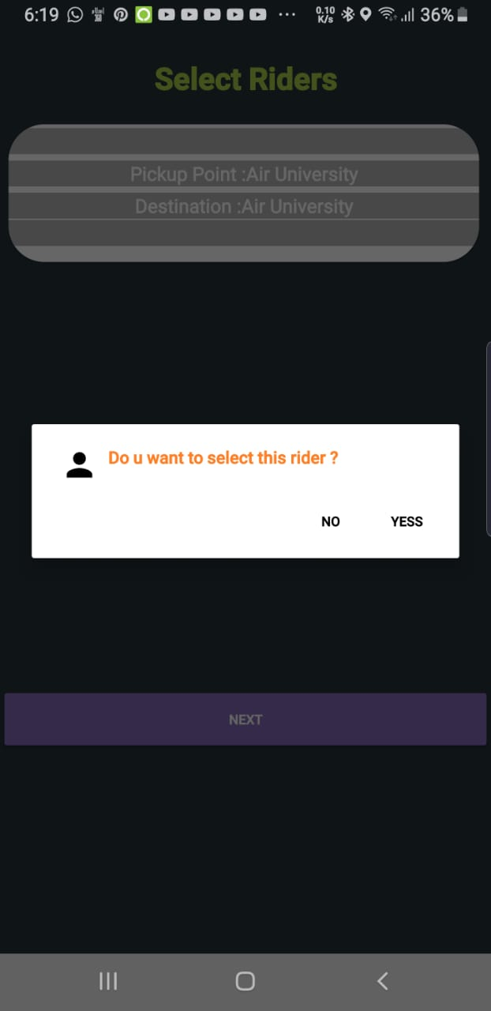 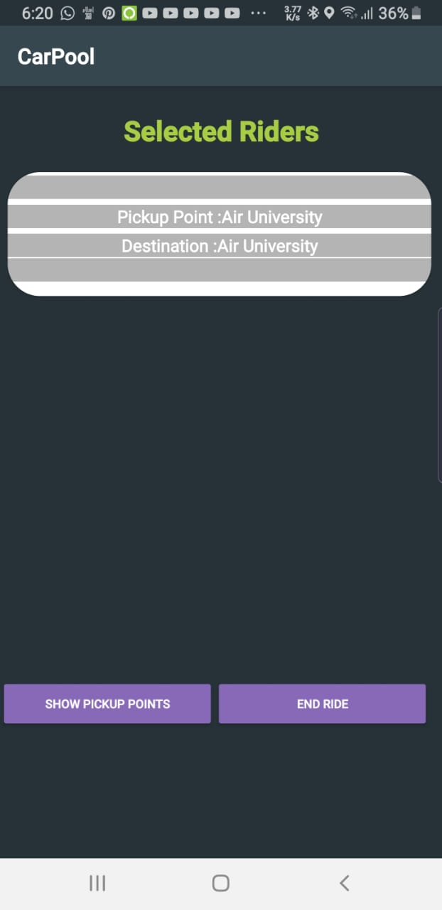 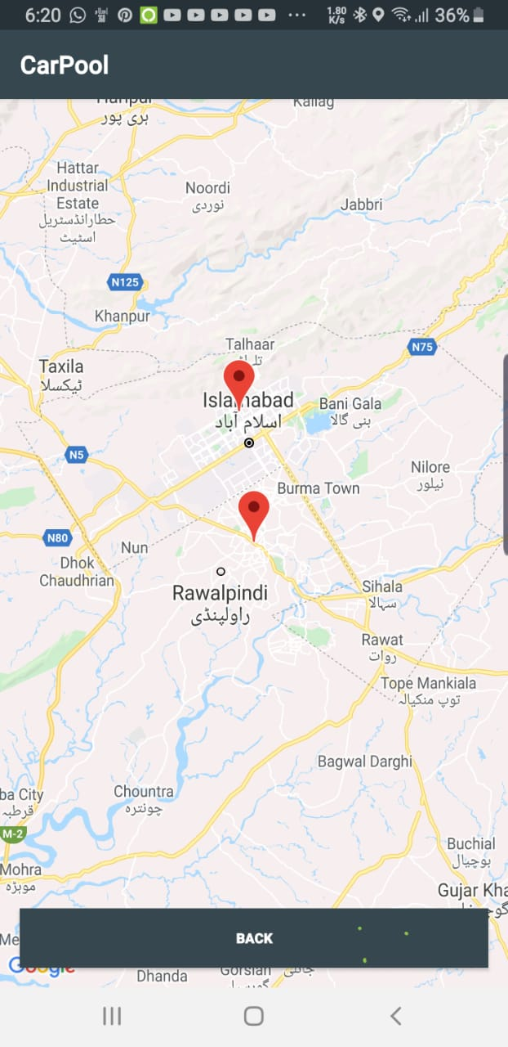

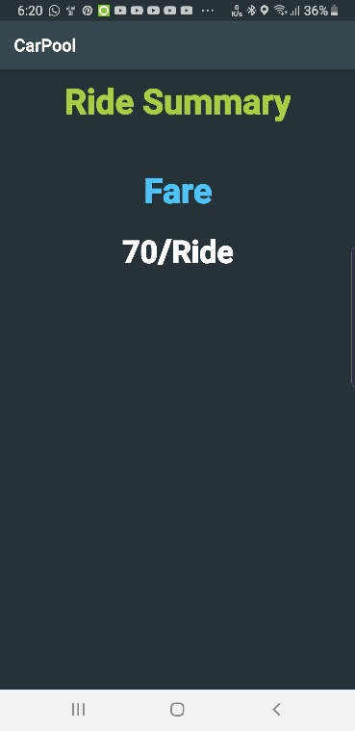

# 5. System Implementation

### 5.1 SystemArchitecture

Application architecture is a set of technologies and models for the development of

fully-structured mobile programs based on industry and vendor-specific standards. As we develop the architecture of our application, we also consider programs that work on wireless devices such as smartphones and tablets.

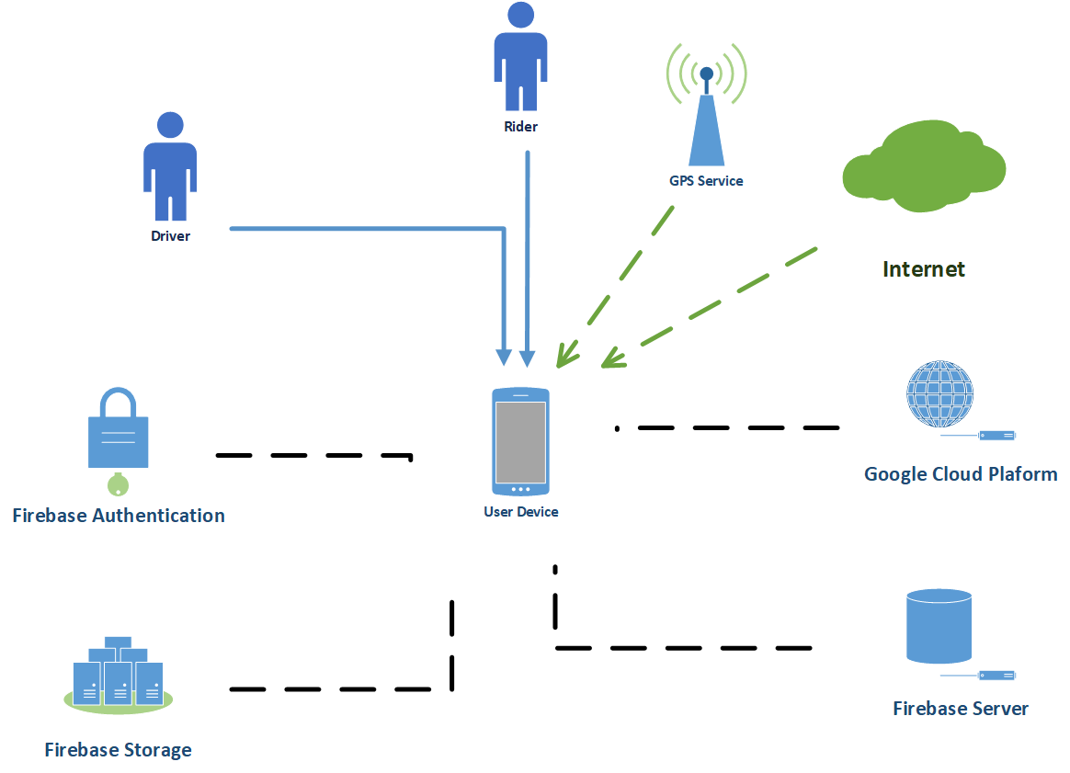

Figure 7: System Architecture

### 5.2 Work Environment

### 5.2.1 Hardware platforms

For the development of this application we have used an Hp Elitebook workstation 8460w

it fairly powerful and could handle the usage of multiple

emulators at once. Full Specifications:

● Processor : Intel® Core™ i7-2630QM Processor (2.0 GHz, 6 MB L3 Cache)

● Memory : 12GB 1333 MHz DDR3 SDRAM (2D)

● Graphics : AMD FirePro™ M3900 w/1 GB gDDR3

● HDD Drive : 1TB

For the testing of the application on a real device we have used an

Android Phone Samsung Galaxy Note 8, Huawei Mate 10 Pro

### 5.2.2 Software platforms

As for the software part of the work environment we have used several tools

and frameworks alongside different versions of android.

### 5.2.3 Work Tools

● Operating System : Windows

● **IDE** : Android Studio 3.2.1

● **Emulators** : Pixel 3 Android 9 / Nexus 5 Android 6

**● Real Device OS**: Android 9 Pie (Samsung Galaxy Note 8)

● **Backend Management**: Firebase Platform

● **Places and Map Tools**: Google Cloud Platform

### 5.2.4 Programming languages:

● **Application Programming** : Java

Motivation: Java code is inherently safer than Kotlin code because it

prevents common programming mistakes by design, resulting in fewer

system failures and application crashes. When using Kotlin, certain error

causes are more likely to occur again.

● **Layout Design :** XML

**● Database Language :** NoSQL

### 5.2.5 Frameworks used:

**• Firebase Auth :** this framework that lets you implement easy Authentication in this

application email and phone number authentication was used.

• **Firebase Real-time Database** : this framework is used as our main Database for

this application it lets you read and write data from firebase in a NoSQL structure.

• **Firebase Storage** : this framework is used to upload and download data such as

photos and videos, this is used to store user pictures for our database.

• **Firebase Messaging** : a framework that makes real time messaging easy and

possible using firebase, it’s also used for push notifications, this used for our

messaging function between users in our application.

• **Google Maps API** : a great API used for MapView that enables the application to

show places on the map like the origin and destination and the way between them,

it’s used in the map to trace the destination on the map for users.

• **Google Places API** : a very powerful API used to give information about places in

the application and used to AutoComplete search queries, it’s used to autocomplete

search queries for our users for easier searching, it’s also used to optimize our

search function.

• **Material Design Library** : Material Design Library with all of its components such

as Material Buttons, Material EditText etc..

• **RuntimePermission** : a small library to help manage Android Permissions with no

problems.

• **DxLoadingButton** : a small library with a loading button used for Authentication.

• **StfalconImageViewer** : a simple and customizable Android full-screen image

viewer with shared image transition support, "pinch to zoom" and "swipe to

dismiss" gestures.

• **Spinner** : A styleable drop down menu for Android using the old spinner style.

• **Tooltip** : Simple to use customizable Android Tooltips library based on

PopupWindow.

• **EasyValidation** : A text and input validation library in Java for Android. Used to

validate user input info.

• **Retrofit** : Type-safe HTTP for Android and Java.

### 5.2.6 Database Management System

To manage the backend of our application we decided to use Firebase Real-time

Database alongside with Firebase Auth and Firebase Storage.

**• Firebase Real-time Database :**

it’s a database structured in a NoSQL way, it’s usage is very easy and very fast, we

have used this database to store User objects which contain all the information about the

user such as name, email, number etc., we have also used it to store Trip and TripRequest

objects ..

example of the user node in the database:

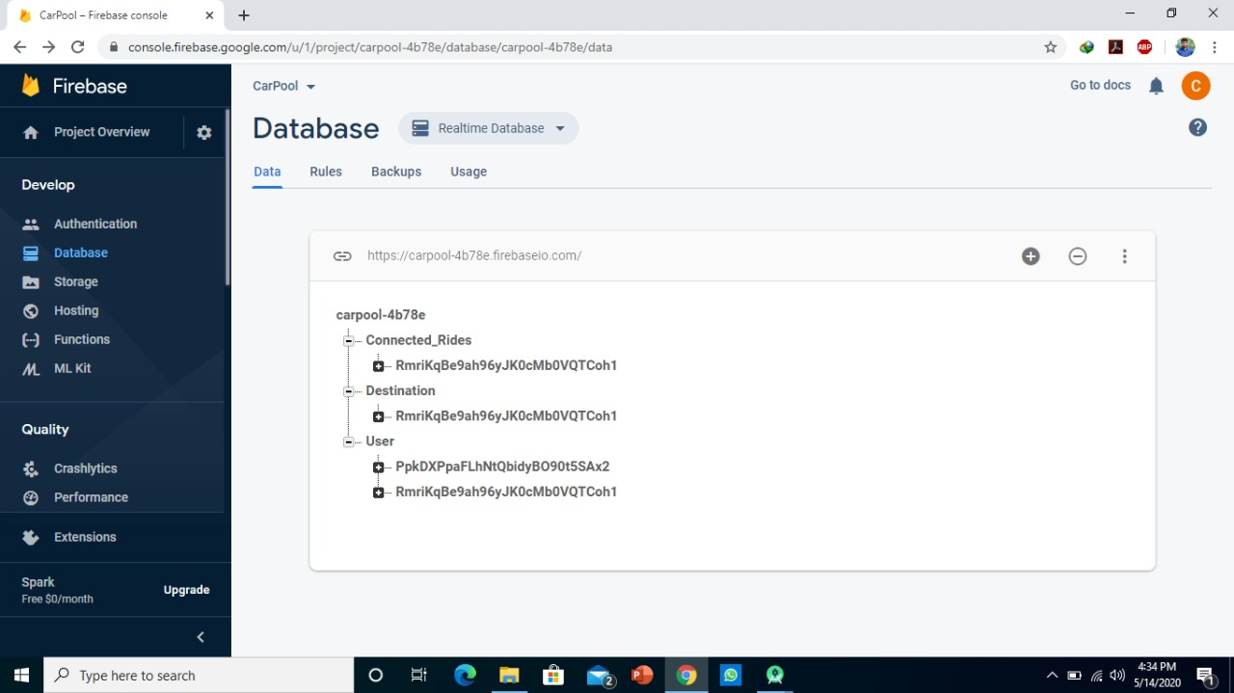

example of a user mode in the database

• **Real-time Database Usage:**

For the usage of this Database a separate Database class was made on Java this

class contains all Database related functions the functions require a listener interface that

has **onStart(), onSuccess(), onFailed(),** the interface is used to listen to changes in other

classes.

The reason for creating a separate class with a listener interface is to make

migration to another Database easier. If we ever decide to switch to another database we

will only change the content of the Database class which would make changes faster, more

professional and effective.

Firebase’s Real-time Database allows you to use different query methods

to fetch data from its Database:

The first method is using **addListenerForSingleValueEvent,** this method listens to changes

in data for one time and does not trigger until it’s called again, this is good for fetching data

only once.

The second method is using **addValueEventListener,** this method listens

to data every time it changes and it also triggers every time it changes this is

good for things like messages and real time updates.

In our real.

We have decided to use **addListenerForSingleValueEvent** for most of our data

fetching, the reason is each time data has been read, Firebase charges for it, which means

it the less data is fetched the better, for this we have avoided using **addValueEventListener**

Instead we fetch the data once and save it locally, when the data is changed the user is

required to refresh the page to get updates. However in cases where it’s important to get

updates in real time like in messages we have used **addValueEventListener**.

### 5.3 Tools & Technology

* Android
* Firebase Platform
* Google Cloud Platform
* Android Studio
* Java Language
* Google Maps API
* Google Direction API
* Google Places API

### 5.4 System requirements

* Android phone with Minimum SDK android API 19 Kit Kat
* Google Play Services
* GPS service
* Internet Connection

### 5.5 Security

• **Firebase Authentication:**

Firebase Authentication is a very fast and secure way to sign users into our

application it is used to Login and Register users into our database in our case we are using

the email verification, a user must verify his email to complete the

registration.

• **Authentication Usage:**

When a user registers, his basic information (Name, Email, Password) are

registered in the Auth Database but not the RealTime Database, after that users are

welcomed with a finish registration activity, in this activity they have to verify their email

using EMAIL verification, this method is used to prevent spam and multiple account

creations, after verification and filling other information user data is saved on the RealTime

Database. As for the login the system checks data and logs users if it’s correct.

### 5.5 Rules

Some of the restriction and rules are mentioned below

* User can be used one account for both driver and rider.
* Users cannot modify anyone else’s data except theirs.
* Only the admin can modify the data of other users.
* The driver cannot select more than three riders.
* The rider can only contact with their driver.
* A rider have to select pick up and drop off points.
* Driver, Rider cannot use the app until their accounts are verified.

# 6. System Testing and Evaluation

### 6.1 Graphical user interface testing

Table 35: user interface testing

|  |  |  |  |  |
| --- | --- | --- | --- | --- |
| **No** | **Test Objective** | **Test Step** | **Expected Result** | **Result** |
| **1.** | Check the color and size of buttons on the home screens of different users. | 1) Make boundaries visible after activating developer mode in your android phone  2) Open all the users home screen one by one and you will feel the difference | Buttons size and color must be same in all user dashboards | Affirmative |
| **2.** | Make sure that icons pixels won’t fall when the app would be opened on different screen sizes. | 1) Open your app on the screen of different sizes. | Icons appearance would be the same on all screens. | Affirmative |
| **3.** | Ensure the ripple effect working on all buttons. | 1) Check by pressing all the buttons added in-app. | Ripple effect will generate when you will press button | Affirmative |
| **4.** | Is text visible on smaller screens? | 1) Open the app on small screens. | The text is readable by the user. | Affirmative |
| **5.** | Buttons must be separated by some distance so the user won’t press the wrong button. | 1) Press the buttons that are placed together or have little distance | The user was able to press the desired button with his thumb | Affirmative |

### 6.2 Usability Testing

Table 36: Usability Testing

|  |  |  |  |  |
| --- | --- | --- | --- | --- |
| **No** | **Test Objective** | **Test Step** | **Expected Result** | **Result** |
| **1.** | To check registered on CarPool . | 1) Press the sign up button.  2) Fill the form.  3) Accept only university email for sign up.  4) Send verification email on email.  5) After verification process account has been created. | User will be able to use this application. | Affirmative |
| **2.** | Forgot Passwrod ? | 1) Click the forgot password button.  2) Text box will appear enter registered email.  3) Press reset button email has been sent to your email.  4) Check your email and set your new password. | Account password reset. | Affirmative |
| **3.** | Login to Carpool application. | 1) Enter registered email.  2) Enter account password.  3) Press login button. | User login to application | Affirmative |
| **4.** | Select user type driver. | 1) Login in to the application.  2) Switch button to driver type.  3) Enter vehicle details and press next button to update details in database. | User act as a driver. | Affirmative |
| **5.** | Check as If a driver can select riders. | 1) Login as a driver.  2) Enter vehicle details.  3) Show riders list.  4) Select riders. | Riders selected and send driver details to riders. | Affirmative |
| **6.** | Check can driver see pick up points of selected riders ? | 1) Display list of selected riders on screen.  2) Press button show pick up points.  3) Display pick up points of riders on map. | Driver will be able to see the pickup points of riders. | Affirmative |
| **7.** | Drop off riders on different location. | 1) Select rider pop up will appear.  2) Press drop off.  3) Rider eliminate from pick up list | Rider drop off on their location. | Affirmative |
| **8.** | Ride summary  display. | 1) Drop off all riders one by one or press the end ride button .  2) Ride summary will appear. | Display ride summary. | Affirmative |
| **9.** | Select user type rider. | 1) Login in to the application.  2) Switch button to rider type.  3) Rider have to select destination and pick up point.  4) Press next button and user current location, drop off and pick up point display on map. | User act as a rider. | Affirmative |
| **10.** | Notify details of driver to rider. | 1) After enter ride details a waiting screen will display.  2) When rider select by driver details of driver will be display on rider screen.  3) When driver pick up rider press start ride button. | Details of driver will be shown to rider. | Affirmative |
| **11.** | Show summary of ride to rider. | 1) when driver drop off rider press end ride button.  2) Ride summary display on screen. | Show ride summary. | Affirmative |

### 6.3 Software performance testing

Table 37: performance testing

|  |  |  |  |  |
| --- | --- | --- | --- | --- |
| **No** | **Test Objective** | **Test Step** | **Expected Result** | **Result** |
| **1.** | To check as if the app would work smoothly when multiple riders selected by a driver. | 1) Create multiple accounts and put ride details.  2) Select by single driver. | The speed of the app won’t be affected. | Affirmative |
| **2.** | Check the speed of the app after registered multiple accounts . | 1) The app would work as it used to work with twenty complaints. | The speed of the app won’t be affected. | Affirmative |
| **3.** | To check firebase cloud speed. | 1) Ask multiple drivers to enter vehicle details and select riders from list.  2) Ask multiple riders to enter ride details and selected by drivers ]. | App performance won’t be affected. | Affirmative |

### 6.4 Compatibility testing

Table 38: Compatibility testing

|  |  |  |  |  |
| --- | --- | --- | --- | --- |
| **No** | **Test Objective** | **Test Step** | **Expected Result** | **Result** |
| **1.** | To check as if the location of the user keeps on updating when user is moving. | Sign in to the driver and rider account. | It will keep on updating the current location. | Affirmative |
| **2.** | Ensure the readability of text on different screens. | Open your app in different screen sizes. | The user would be able to read the text on small screens | Affirmative |
| **3.** | Push Notifications keep on coming on different mobile devices. | Using the app on different android versions. | Notifications would display on the notification screen. | Affirmative |

### 6.5 Exception handling

Table 39: exception handling

|  |  |  |  |  |
| --- | --- | --- | --- | --- |
| **No** | **Test Objective** | **Test Step** | **Expected Result** | **Result** |
| **1.** | Only university email format required for signup; Invalid email won’t be accepted. | Enter the email while registering your account. | Registration successful. | Affirmative |
| **2.** | If email is not verified by, the user won’t be able to sign in the app. | Verification email has been sent to email, when he registers an account. | Account verification done. | Affirmative |
| **3.** | An invalid phone number is not allowed. | Write a valid number. | The phone number verified. | Affirmative |
| **4.** | Users not allowed to enter the same email twice. | Enter a new email if you want to register your account. | The unique email entered and account approval request sent to admin. | Affirmative |
| **5.** | The app won’t crash if user do not allow location permission. | Application ask to access the user current location. | App working fine. | Affirmative |
| **6.** | Users can’t edit roll number or email after signup. | Register your account. | Unable to edit email or roll number. | Affirmative |
| **7.** | Only selected riders will be notify by driver details. | Select riders from list and send detail of driver to specific riders only. | Notify the details of drivers to selected riders. | Affirmative |

### 6.6 Security testing

Table 40: Security Testing

|  |  |  |  |  |
| --- | --- | --- | --- | --- |
| **No** | **Test Objective** | **Test Step** | **Expected Result** | **Result** |
| **1.** | Eliminate the risk of password leakage when someone tries to guess the password of the user. | 1) Try to guess the password of some random user. | It won’t work as the user was forced to create a strong password involving numbers and symbols during the signup process. | Affirmative |
| **2.** | Prevention of a denial of service attack by an attacker. | 1) Detect vulnerabilities in the application layer. | Denial of service attack passed. | Affirmative |
| **3.** | Reduce the risk of SQL injection. | 1) User is unable to write a query in any text box with the use of proper validation in different forms. | Validations stopped the execution of the query. | Affirmative |
| **4.** | To validate an attacker from accessing sensitive data. | 1) Try to extract extra data from the admin side. | Data won’t be extracted with the proper use of validations. | Affirmative |
| **5.** | To analyze the vulnerability of file system interactions. | 1) Allowing the user to only add jpg/png files while uploading fees challan. | Malicious data won’t get uploaded. | Affirmative |

### 6.7 Installation testing

Table 41: installation testing

|  |  |  |  |  |
| --- | --- | --- | --- | --- |
| **No** | **Test Objective** | **Test Step** | **Expected Result** | **Result** |
| **1.** | Install the app on different android versions starting from 4.4 to 9.0. | Install the app using the .apk file. | The app would be installed successfully. | Affirmative |
| **2.** | To check as if an app installed with all resources. | Open the app. | App working as explained by the developer. | Affirmative |
| **3.** | Try uninstalling the app from the android phone. | Click on uninstall option |  | Affirmative |

# 7. Conclusion

Appendix A

# User Manual

# References

[1] OwanaMarziaMoushi, Mostofa Kamal, Mahmuda Haque and Md. Shamim,“Design and Development of an Online Bus Monitoring System”, 10th International Conference on Electrical and Computer Engineering 20-22 December, 2018, Dhaka, Bangladesh

[2] K Sujatha, K J Sruthi, P V Nageswara Rao and A Arjun Rao, “Design and Development of Android Mobile Bus Tracking System”, 2014 First International Conference on Networks & Soft Computing,

[3] globalmissing.org, “Missing children’s statistics”

[4] Jisha R C, Mathews P Mathews, Sidharth P Kini, Vineeth Kumar, Harisankar U V, Shilpa M, “An Android Application for School Bus Tracking and Student Monitoring System”, 2018 IEEE International Conference on Computational Intelligence and Computing Research

[5] Bhavani, Durga & S C V S L S, Ravi Kiran. (2017). Implementation of Smart Bus Tracking System Using Wi-Fi. 6. 12940-12946. 10.15680/IJIRSET.2017.0607082.

[6] Sharif, Shafri & Suhaimi, Mohd & Jamal, Nurul & Riadz, Irsyad & Amran, Ikmal & Jawawi, Dayang. (2018). Real-Time Campus University Bus Tracking Mobile Application. 1-6. 10.1109/ICT-ISPC.2018.8523915.